Demo A Specification

Version 0.1

Version | Date | Author | Comments
0.1 | 08/05/04 | SWD | Initial Draft

Introduction 2
Goals 2
Customer Timeline 2
State of the document 2
Requirements 2
Hardware 2
Software 3
User scenarios 4
Scenario 1 4
Scenario 2 5
Holes in the demo 5
High-Level Workflow 6
Modality sends images to PurpleBoxA 6
PurpleBoxA sends documents to PurpleBoxB 7
PurpleBoxB sends documents to WorkstationB 8
Tasks 8

Introduction

Goals
- Help define the specification for further development.
- Establish working relationship with customer.
- Help customer define their business model(s).
- Help customer get 5 year grant renewal in February.

Customer Timeline
The customer would like to begin testing as soon as possible. The firm deadlines for this project are:
- November 2: Mock site visit. Some parts of the system need to be ‘live’ by then.
- February 1: 5 year renewal of grant by National Cancer Institute; includes site visit.
- Spring 2005: Live clinical applications.

There will be a number of upgrades to the customer’s site to ensure that the system does what it needs to do.

State of the document
This is a rough draft. Still to do:
- Integrate details from Bill’s document “Non-Medical MedCommons Infrastructure”. For example: are we going to put in Zabbix agents in Demo A?
- Integrate more of Adrian’s notes from last night’s talk (which objects have GUIDs, where state is tracked, … &etc).

Requirements

Hardware
There are three boxes under the control of MedCommons in Demo A. Two are purple boxes, one is a pink box. In this document they are referred to as PurpleA, PurpleB, and PinkA. The two purple boxes are identical with the possible exception of some configuration files.

The entire hardware configuration of the demo includes:
- PurpleBoxA: purple box at SiteA
- PurpleBoxB: purple box at SiteB.
- PinkBox: location unclear.
- ModalityDeviceA: source of data for DemoA.
- WorkstationB: recipient of data for DemoA.

Software
There are more requirements; we’ll have to group them as this document grows.

- Purple and Pink boxes must be running PCAnywhere running under WindowsXP. Eventually we will move to Linux; in the short run Windows is what we can support.
- The functionality would be the "minimum subset" of that which is in the WADO Viewer and Control Screens (https://www.medcommons.net:6666/svn/documents/Requirement%20Specs/Control%20Screens/Tracked_Objects.htm). The minimum subset is defined as:
  - PurpleBoxA must accept DICOM from one modality and declare a Study complete by a simple 30 second time-out rule. [Other rules to be added in the future]
  - Autoroute the Study to PurpleBoxB and then to DICOM WorkstationB such as eFilm or Vitrea without any human intervention.
  - Have the Study in question show up in the Worklist display with a Tracking Number and a Status.
  - Show the Study in the WADO Viewer if someone clicks on the Tracking Number in the Worklist.
- Software must be monitorable.
- Software must report errors so that it can be maintained/fixed.
- Software must be able to be updated in the field with a simple set of procedures.

User scenarios

For the purposes of this document two clinical sites are named SiteA and SiteB. These sites can be hospitals, imaging centers, or laboratories performing work on images. The only technical requirement is that SiteA puts documents into MedCommons and SiteB receives documents from MedCommons. For the initial demonstration all transfers are DICOM transfers – so this means that SiteA has a DICOM CSTORE SCU and that SiteB has a DICOM CSTORE SCP.

In practice the roles of SiteA and SiteB may be reversed for images sent back to the original site – the MedCommons software at both sites is identical.

In this document the following conventions are used:
- If a person’s name ends with “A” they are at SiteA; if their name ends with “B” they are at SiteB.
- There are three roles defined in the scenarios:
  - RadTech – a radiology technologist. The person who operates a modality device such as an MR or CT scanner.
  - Radiologist. The person who looks at a study and renders a diagnosis. In this example it is assumed that the radiologist is the one receiving the images on a DICOM workstation – in practice this may or may not be true (sometimes trained technicians operate these machines). For the purposes of this document the people looking at the images on radiology workstations are radiologists.
  - Site Manager. A Site Manager is the person who looks at the workflow screens to see what is going on; they also are the primary contact with MedCommons for problems with the units.

Scenario 1

RadTechA wants to send a DICOM study to the TumorWorklistB. RadTechA selects the study to be sent and transmists the study to PurpleBoxA. The DICOM study is sent from RadTechA’s DICOM device (it might be a PACS or a modality) to PurpleBoxA using the TumorB AE title. When the DICOM transfer to PurpleBoxA is complete RadTechA’s job is done.

RadiologistB sits at DICOM WorkstationB at SiteB. The DICOM study from SiteA is sent to this device via PurpleBoxB. RadiologistB knows that the study is available for viewing when it appears on their local workstation.

Scenario 2
Use worklist on pink box to
- Look at status;
- Launch WADO viewer.
Details TBD.

Holes in the demo
This section identifies holes in the demo. There is no implication here that the holes need to be filled with any particular solution; many of the holes we want the customer to characterize. Here we simply identify

- There is no mechanism for results to be returned from SiteB to SiteA. The customer has not yet defined what their results will be (text files, DICOM structured reports, XML documents…). Disposition: Waiting for customer input.
- Auditing/Tracking. What do they need to get their job done? Disposition: Waiting for customer input.
- DICOM Query/Retrieve missing. Disposition: perhaps in Demo B; possibly in Demo A if Adrian requires.

High-Level Workflow

Note that the processes are just labeled as the box that they are in. A more detailed design will identify the actors/processes within the Purple and Pink boxes that send and receive messages.

Modality sends images to PurpleBoxA
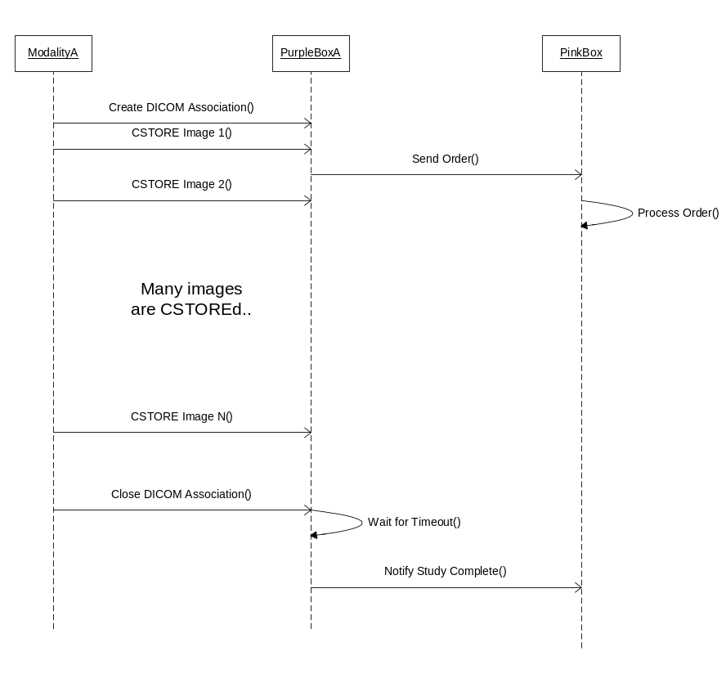

PurpleBoxA sends documents to PurpleBoxB

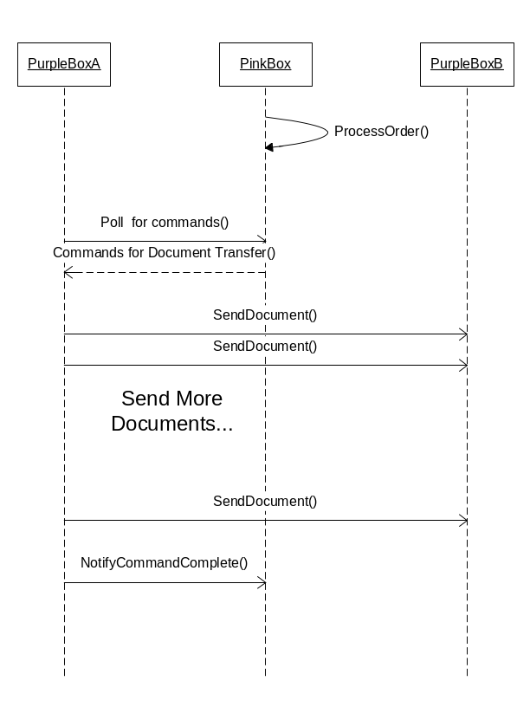
Not shown: updates of status on pink box.
Ambiguously shown: Are documents sent in one call or several calls? Is document transfer started after the “NotifyStudyComplete” or after “SendOrder” from the previous sequence diagram?

PurpleBoxB sends documents to WorkstationB
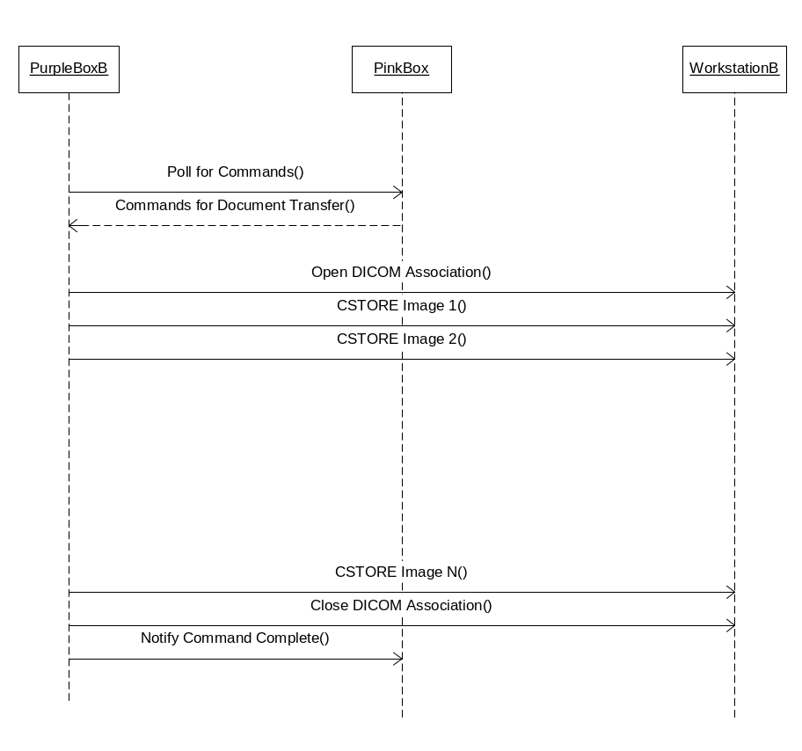

TBD: sequence diagrams for worklist/status/WADO viewing.

Tasks
Tasks are in no particular order. This section will be reorganized as we go.

- Add database to demo. Needed for handling more DICOM services. Includes adding Hibernate to manage the layer between Java and the database. First database is HSQL.
- Define purple box tables.
  - Patient/study/series/image
  - CSTORE transfer tables
- Define some pink box tables:
  - DICOM device table for virtualization.
  - Worklist(s)
  - User(s)
- Define structure of order form.
- Define APIs for ImageExpress

